MPSG ANNUAL EXTENSION REPORT
Manitoba Survey and Molecular Quantification of Soybean Cyst Nematode
PROJECT TITLE:
PROJECT START DATE: 1 April 2017 | PROJECT END DATE: 31 March 2019
DATE SUBMITTED: 22 August 2018

PART 1: PRINCIPAL RESEARCHER
PRINCIPAL
NAME: | Mario Tenuta | NAME:
POSITION: | Professor | POSITION:
INSTITUTION: | University of Manitoba | INSTITUTION:
EMAIL: | mario.tenuta@umanitoba.ca | EMAIL:
PHONE: | 204-474-7827 | PHONE:

PART 2: EXECUTIVE SUMMARY
This project continues the proactive role of the Univerity of Manitoba and MPSG in knowing when SCN has arrived in the Province, outreach activities to inform growers about SCN and develop capacity within the Province for future surveys and research to mitigate damage due to SCN after its arrival. The project has three objectives;
1) Survey soybean fields for SCN
2) Publish results of this and the past two SCN surveys
3) Develop accurate and quick molecular method for quantification of SCN in soil

25 soybean fields will be surveyed. In addition, fields of a seed potato grower in North Cypress will sampled. Each field will be sectioned into areas prone for the establishment of SCN. Areas will be sampled to 12” with 10 to 25 sub-samples taken for each, depending on section area. Soil from each area will be air-dried and 2.5 lbs will be extracted using a cyst extractor. Extracted cysts will be isolated from soil debris by flotation in ethanol. They will then be screened for belonging to the genus Heterodera based on vulval cone structure and being lemon-shaped cysts. The cysts of Heterodera will then be sorted if being SCN using identification keys. Suspect SCN cysts will then be confirmed using PCR methods. Only samples being positive by morphological and molecular examination will be considered to be SCN. Postive field will be resampled.

We propose to develop an acurate and quick molecular method by skipping the most laborious steps (crushing and counting) and then manual SCN identification. Instead we propose a genonomic DNA extraction of isolated cysts with quantification using the CoxII gene and real time PCR. Twenty soils from Ontario ranging from none to extremely
Outline the project objectives, their relevancy to pulse and soybean farmers, and a summary of the project to date, including methods and preliminary results.

PART 3: PROJECT ACTIVITIES AND PRELIMINARY RESULTS
The current project was initiated between the University of Manitoba, the Manitoba Pulse Growers Association,Manitoba Agriculture, Food and Rural Affairs and the Western Grains Research Foundation to survey for the presence of SCN in Manitoba.In this study, 30 commercial soybean fields in Manitoba near the U. S. border with history of soybean and edible bean cultivation were sampled (Fig 1A). Each field was segregated into three to six risk areas for SCN introduction such as entrance ways, depressions and headlands (Fig 1B).

A total of 90 composite soil samples were obtained for about 3 samples for analysis per field. A modified Fenwick elutriator (soil washing unit) based on the USDA soil cyst extractor was first tested in terms of recovery efficiency (%70) and then 2.2 kg of each soil sample was used to recover nematode cysts (Fig 1C). Cysts were extracted from debris obtained from the elutriator by using ethanol flotation. Cyst identification was performed based on morphology and microscopy analysis. Recovered cysts were examined for shape and vulval cone top structure (circumfenestrate and bifenestrate) . Cysts will then follow up with molecular analyses by SCN species-specific PCR approaches, and We will use the published SCAR and newly developed CoxIII primer set that our laboratory has shown able to identify SCN from Ontario and U.S. (Ou et al. 1993, Subbotin et al. 2001, Madani et al. 2013).

Overall, 17 of the composite samples from 12 fields had nematode cysts. One to a few cysts were recovered from each of these 17 composite samples. In total, 42 cysts were recovered. Out of the 42 cysts recovered, half (21) were lemon shaped as expected of SCN, and the other half were round shaped (Table 1), the cysts also were intact for morphological and molecular examination. Based on the morphological findings of our study no lemon-shaped cyst with bifenestrate vulval cone structure (characteristics of the genus Heterodera) has yet been identified(table 1.2), and This study continues to identify remaining cysts based on morphology and genetic structure to address the question, “is Manitoba still free of the soybean cyst nematode?”

We will draft a publication with the results of the past SCN surveys and the current one.

We have been using a PCR method based on two different genes developed by the laboratory to identify for SCN in the current survey. The methods will be included in the survey publication.

Outline project activities, preliminary results, any deviations from the original project and communication activities. You may include graphs/tables/pictures in the Appendix.

APPENDIX

Table1. Occurrence of Cyst Forming Nematodes in Soybean Fields in Manitoba

Fields | Sample code | Cyst found | Cyst shape |  | Fields | Sample code | Cyst found | Cyst shape
1 | 1-1  1-2  1-3 | 0  1  0 | Round |  | 16 | 16-1  16-2  16-3 | 0  0  0 | NA
2 | 2-1  2-2  2-3 | 0  0  0 | *NA |  | 17 | 17-1  17-2  17-3 | 0  0  0 | NA
3 | 3-1  3-2  3-3 | 1  0  2 | Lemon-shaped  Round-Round |  | 18 | 18-1  18-2  18-3 | 5  13  0 | 4 lemon-shaped  7 Lemon-shaped
4 | 4-1  4-2  4-3 | 0  0  0 | NA |  | 19 | 19-1  19-2  19-3 | 0  0  0 | NA
5 | 5-1  5-2  5-3 | 1  0  0 | Round |  | 20 | 20-1  20-2  20-3 | 0  0  1 | Round
6 | 6-1  6-2  6-3 | 0  0  0 | NA |  | 21 | 21-1  21-2  21-3 | 0  0  0 | NA
7 | 7-1  7-2  7-3 | 0  0  0 | NA |  | 22 | 22-1  22-2  22-3 | 1  0  0 | lemon-shaped
8 | 8-1  8-2  8-3 | 0  0  1 | Lemon-shaped |  | 23 | 23-1  23-2  23-3 | 0  0  0 | NA
9 | 9-1  9-2  9-3 | 0  0  0 | NA |  | 24 | 24-1  24-2  24-3 | 0  0  0 | NA
10 | 10-1  10-2  10-3 | 0  0  0 | NA |  | 25 | 25-1  25-2  25-3 | 0  0  0 | NA
11 | 11-1  11-2  11-3 | 1  1  0 | Round  Round |  | 26 | 26-1  26-2  26-3 | 0  0  0 | NA
12 | 12-1  12-2  12-3 | 8  0  0 | 7 Lemon-shaped |  | 27 | 27-1  27-2  27-3 | 1  0  0 | lemon-shaped
13 | 13-1  13-2  13-3 | 0  0  0 | NA |  | 28 | 28-1  28-2  28-3 | 1  1  2 | Round  Round  Round-Round
14 | 14-1  14-2  14-3 | 0  0  0 | NA |  | 29 | 29-1  29-2  29-3 | 0  0  1 | Round
15 | 15-1  15-2  15-3 | 0  0  0 | NA |  | 30 | 30-1  30-2  30-3 | 0  0  0 | NA
*NA= not applicable

Table2. Summary of cyst content and vulval cone structure have been done so far.
Sample code | Cysts | Cyst content | Vulval cone top
1-2 | A | Eggs & Juveniles | Bifenestrate
3-1 | A | Eggs & Juveniles | Circumfenestrate
3-3 | A | Empty | Bifenestrate
 | B | Eggs & Juveniles | Bifenestrate
5-1 | A | Empty | Bifenestrate
8-3 | A | Eggs & Juveniles | Circumfenestrate
11-1 | A | Empty | Circumfenestrate
11-2 | A | Empty | Bifenestrate
12-1 | A | Eggs & Juveniles | Circumfenestrate
 | B | Empty | Circumfenestrate
 | C | Eggs & Juveniles | NA
 | D | Empty | NA
 | E | Empty | Circumfenestrate

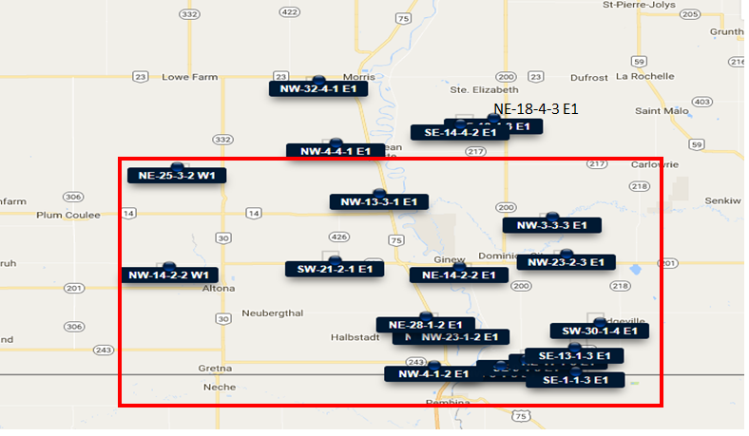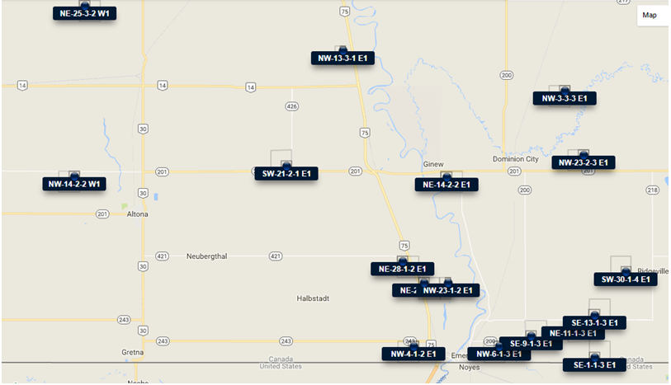
1A.
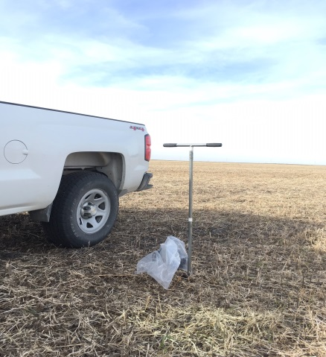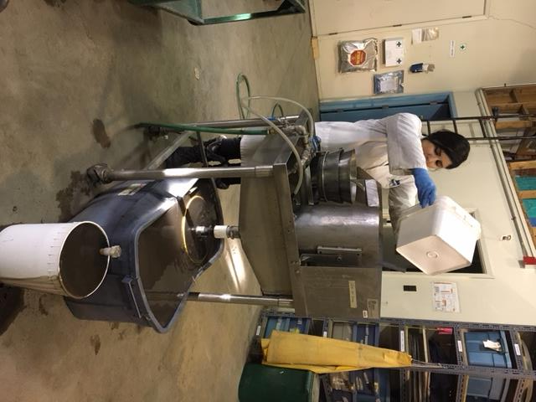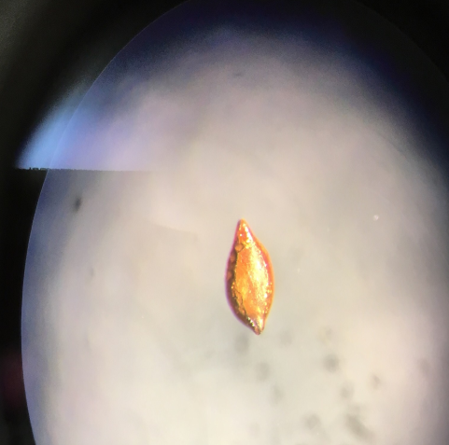
1B. 1C. 1D.

Figure1. 1A) Locations of soybean fields. 1B) Soil Sampling. 1C) Soil washing unit. 1D) Lemon-shaped cyst

