MPSG FINAL EXTENSION REPORT
Mitigating the deleterious effects of above normal soil moisture on the productivity of pulse crops through seed treatment
PROJECT TITLE:
PROJECT START DATE: 1 April 2014 | PROJECT END DATE: 31 March 2018
DATE SUBMITTED: 24 May 2018

PART 1: PRINCIPAL RESEARCHER
PRINCIPAL
NAME: | Belay Ayele
POSITION: | Associate Professor
INSTITUTION: | University of Manitoba
EMAIL: | belay.ayele@umanitoba.ca
PHONE: | 204-474-8227

PART 2: EXECUTIVE SUMMARY
Outline the project objectives, a summary of the activities and results, and their relevancy to pulse and soybean farmers.

In Manitoba, excess soil moisture is one of the most important factors affecting the productivity of crops in the agricultural industry. Excess moisture in the soil creates a low oxygen environment that negatively affects crop growth and development, and overall yield. The negative effects of excess soil moisture on crops is often associated with the production and accumulation of toxic substances. Plant growth regulators have been shown in mitigating the effects of different abiotic stress factors on crop performance and yield partly through increasing the production and activity of anti-stress proteins, which can limit the production of toxic compounds and thereby damage to the plants. Soybean and pulse crops such as field peas and edible beans are among the most important crops of Manitoba that are vulnerable to excess moisture stress, especielly during the early stages of their development. The main objective of this research is therefore to evaluate the effect of treatment of soybean, field peas and edible bean seeds with specific growth regulating compounds in enhancing their performance under excessive soil moisture. Furthermore, it examines if treatment of established plants with such compounds improves their performance under excessive soil moisture . Using the CDC Meadow, 25-10RY and Windbreaker varieties of field pea, soybean and edible bean, respectively, this study investigated the effects of seed and plant treatments with selected growth regulators on the germination, seedling vigor, and accumulation and activity of anti-stress proteins under excess moisture conditions.

PART 3: EXPERIMENT DESCRIPTION & RESULTS
EXPERIMENTAL METHODS
The study mainly used commercially available plant growth regulators, spermine and spermidine. Peas, soybean and edible bean (pinto bean) cultivars that are commonly grown in Manitoba, CDC Meadow (for peas), 25-10RY (for soybean) and Windbreaker (for pinto bean) were used as experimental plants. To examine the effect of the specific growth regulating compounds in enhancing the performance of pulse crops under excessive moisture stress, mature seeds of the crops studied were treated with solutions containing the different growth regulators at varying concentrations. Seedlings derived from these seeds were grown under above normal soil moisture conditions. The effect of these treatments on germination, growth of the resulting seedlings and physiological responses in terms of tolerance to excess moisture was evaluated. Evaluation of the physiological response was mainly focused on measuring the level of the precursors required for the synthesis of anti-stress proteins, which are involved in reducing the levels of compounds that are toxic to plants and whose production is induced by stress such as excess soil moisture.

RESULTS
Seed germination
The effect of the componds considered for this study on the germination capacity and rate of the seeds of the three pulse crops was evaluated. Our data shows that under normal non-stress conditions, treating the seeds with the three compounds did not affect the germination percentage and rate as the seeds from the three treatments showed similar germination percentage to the untreated control seeds (Figure 1).

Seedling performance under excess moisture
Seedlings from control seeds and seeds treated with the growth regulating compounds were transplanted into pots and grown in a greenhouse. The transplanted seedlings were subjected to excessive soil moisture conditions. Differences in seedling gowth interms of fresh weights and lengths of were compared between the seedlings from control and treated seeds. Under normal soil moisture condition seedlings from control untreated seeds had similar performance in terms of shoot and root growth with those grown from seeds treated with the compounds/growth regulators. However, when the seedlings were grown under excess water conditions, the seedlings (especially field pea and soybean seedlings) resulted from seeds treated with spermine or spermidine, showed better performance with respect to of shoot and root growth in terms of length and weight.

Physiological response under excess moisture
The study also analyzed the effect of seed treatment with the growth regulating compounds on accumulation of precursors required for the synthesis of anti-stress proteins. Our data revealed that the effect of treating seeds with the two compounds on the formation of anti-stress protein precursors varies with the crop, type of tissues and stages of the seedlings. For example, treatments with the two growth regulators appeared to cause significant increases in the amount of the precursors used for the synthesis of specific stress-alleviating proteins in seedling tissues at early developmental stages stages. The treatment also led to significantly enhanced accumulation of the precursors used for the synthesis of specific stress-alleviating proteins in the shoot or root tissues during the later stages. The study in soybean further showed that the treatments with the growth regulating compounds affect the activity of specific stress-alleviating proteins considered in the study. In the case of adult plants under excess moisture, treatment with the compounds increased the accumulation of the precursors of some specific anti-stress proteins that potentially confers the seedlings a capacity to reduce the level of stress-induced toxic compounds and thereby enhanced seedling growth under excess water conditions.
Concisely describe the experimental methods and results to date. You may include up to 3 graphs/tables/pictures in the Appendix.

PART 4: RELEVANCE TO FARMERS AND FUTURE RESEARCH
The specific compounds identified are able to improve the performance of the seedlings of the two pulse crops (peas and edible beans) and soybean during the eraly post germinative stage through altering the level of precursors required for for the syntheis and/or activities of anti-stres proteins. However, as the current study was focused on under controlled environmemntal conditions, the potential of capturing their benefits requires testing their effect under different field conditions. Therefore, the efficacy of these specific compounds under field conditions remained to be studied.
Describe how the project results can be captured to benefit pulse and soybean farmers (production recommendations, innovation items, marketing plans, commercialization of technology etc). Identify any future research opportunities.
PART 5: COMMUNICATION
1. Sidhu GK (2017) Polyamine mediated regulation of enzymatic antioxidative response to excess soil moisture in soybean (Glycine max L.). M.Sc. Thesis, University of Manitoba, Winnipeg, Canada.
2. Park SH, Sidhu GK, Ayele BT (October 25-28, 2016) Polyamine-induced changes in the expression of antioxidative genes in pinto bean seedlings under excess soil moisture. 10th Canadian Pulse Research Workshop, Winnipeg, Manitoba, Canada.
3. Sidhu GK, Ayele BT (June 19-21, 2016) Polyamines-mediated regulation of antioxidative genes and enzyme activities under excess soil moisture stress. Plant Biotech 2016, Kingston, Ontario, Canada.
4. Sidhu GK, Ayele BT (March 19-20, 2016) Polyamines-mediated regulation of antioxidative genes in soybean seedlings exposed to excess moisture stress. Annual Meeting of the Midwestern section of the American Society of Plant Biologists, Brookings, South Dakota, U.S.A.
5. Sidhu G, Ayele BT (July 26-30, 2015) Polyamines-mediated regulation of antioxidative genes in soybean seedlings under excess moisture stress. Annual Meeting of the American Society of Plant Biologists, Minneapolis, Minnesota, U.S.A.
List extension meetings, papers produced, conference presentations made, project materials developed.

APPENDIX
Include up to 1 page of tables, graphs, pictures.

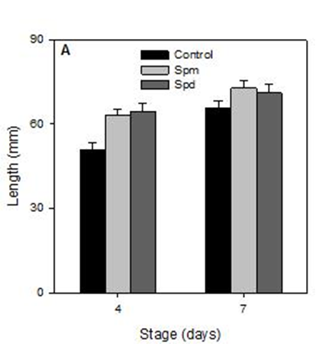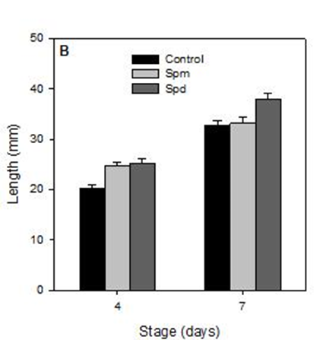

Figure 1. Effects of the growth promoting compounds used in the study on seedling growth of field peas, root (A) and shoot (B)

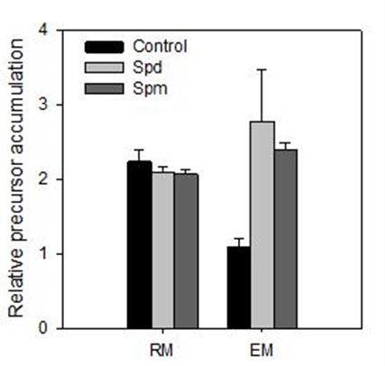

Figure 2. Effects of the growth promoting compounds used in the study on the level of specific anti-stress protein under in seedling tissue regular (RM) and excess moisture (EM).

