**MPSG FINAL EXTENSION REPORT**

**Effect of Soil Temperature at Different Planting Dates, and of Residue Management,**

**on Soybean**

**PROJECT TITLE:**

|  |  |
| --- | --- |
| **PROJECT START DATE: 1 April 2014** | **PROJECT END DATE: 31 March 2018** |

**DATE SUBMITTED: 28 February 2018**

***PART 1: PRINCIPAL RESEARCHER***

**PRINCIPAL**

|  |  |
| --- | --- |
| **NAME:** | Ramona Mohr |
| **POSITION:** | Research Scientist |
| **INSTITUTION:** | AAFC - Brandon |
| **EMAIL:** | ramona.mohr@agr.gc.ca |
| **PHONE:** | 204-578-6556 |

PART 2: EXECUTIVE SUMMARY

*Outline the project objectives, a summary of the activities and results, and their relevancy to pulse and soybean farmers.*

Two complementary small-plot studies were conducted from 2014 through 2017 for a total of 12 site-years, with locations at Brandon, Carberry, Portage and Roblin. The objectives were to determine: Study 1) the effect of soil temperature at two planting dates on soybean growth, yield and quality; and Study 2) the effect of residue management on soybean growth, yield and quality, with the goal of better understanding the relationship between early-season soil temperature conditions and soybean performance.

Research findings suggest that delaying planting beyond the currently recommended planting window for Manitoba of May 15th to 25th into June has the potential to result in significant yield penalties and expose the soybean crop to the risk of fall frost, thereby presenting a significant production risk for growers. For soybean planted on the same date, warmer soil temperatures at planting may sometimes be associated with higher yields than cooler soil temperatures; however, higher soil temperatures did not guarantee improved crop establishment or a yield benefit when soil temperatures were >10 C. Residue management practices such as tillage, and removing surface straw in stubble systems, which were effective in increasing soil temperature at planting to varying degrees depending upon the site and year, only very occasionally influenced yield when soybean was planted during or near to the recommended planting window and soils at planting were greater than or equal to 15 C. Research is ongoing to determine if soil temperature differences may have a more marked effect under more marginal growing conditions (i.e. earlier planting dates with cooler soil temperatures).

***PART 3: EXPERIMENT DESCRIPTION & RESULTS***

Experimental methods:

Study 1. Small plot field experiments were conducted at four Manitoba sites (Brandon, Carberry, Portage, Roblin) in each of 2014 through 2016. A randomized complete block design (RCBD) with four replicates was established, with treatments arranged in a split plot design consisting of two planting dates (main plots) and three soil temperature treatments (subplots). At Roblin only, main plots were not randomized. Planting dates consisted of an earlier and later planting date, with the earlier planting date typically occurring from mid- to late May, and the later planting date typically 9 to 15 days later. Three soil temperature treatments, designated as “cold”, “control” and “warm” depending upon the soil coverings applied, were established as subplots. To produce soil temperature treatments, plots were covered in early spring with: 1) styrofoam and/or reflective material to insulate the soil (“cold”); 2) black plastic to warm the soil (“warm”); and 3) white+clear plastic to reflect the sun (“control”) (Figure 1).

Study 2. Small plot field studies were initiated at four Manitoba sites (Brandon, Carberry, Portage, Roblin) in 2014. Residue management treatments were imposed at each site in 2014, 2015 and 2016, with soybean established into these treatments in each of 2015, 2016 and 2017. A randomized complete block design (RCBD) with four replicates was established, comprised of six residue management treatments: control (wheat residue, tilled), and five stubble treatments (wheat with straw chopped and retained, wheat with straw removed, oat with straw chopped and retained, oat with straw removed, and canola with straw chopped and retained).

In both studies, detailed soil temperature data were collected together with information regarding soybean emergence, yield and quality.

Results to date:

Results of the current study suggest that delaying planting beyond the currently recommended planting window of May 15th to 25th has the potential to result in significant yield penalties and may present a significant production risk. Under the conditions of this study, delayed planting resulted in marked yield declines in most site-years at Brandon, Carberry and Portage (Figure 2). Delaying planting in this study, typically by 9 to 15 days (from the 3rd to 4th week of May into June), resulted in 40 to 80% the yield of the May planting dates depending upon the site-year. Further, at one of three years at Roblin, significant frost damage occurred with the later planting date resulting in neglible yields.

A strong and clear relationship between soil temperature at planting and soybean performance was not evident under the conditions of the current study. In Study 1, soil coverings installed in the field in early spring often produced a range of soil temperatures at planting, and for varying lengths of time thereafter, but differences in soil temperature at planting were not consistently associated with differences in soybean yield (Figure 2). This was the case although soil temperatures at planting were often below the 18 to 22°C suggested as ideal based on current provincial recommendations, and occasionally <10°C. Of five cases where yields were higher in “warm” treatments that had been covered by black plastic than in “cold” treatments covered by Styrofoam, warmer temperatures at planting were evident in the “warm” treatments in only three cases.

Similar general trends were evident in Study 2, which assessed the effect of residue management practices preceding soybean on soil temperature and its relationship to soybean performance. Although residue management frequently influenced early-season soil temperature and/or moisture, and occasionally affected the days to crop emergence, effects on soybean yield were limited (2 of 12 site-years) (Figure 3). In part, because soybeans had been planted within or near to the recommended planting dates for Manitoba and when soil temperatures at planting were equal to or greater than 15 C (Figure 3), the effects of residue management on growth and yield may have been less than under more marginal conditions.

*Concisely describe the experimental methods and results to date. You may include up to 3 graphs/tables/pictures in the Appendix.*

***PART 4: RELEVANCE TO FARMERS AND FUTURE RESEARCH***

The information generated from the current study regarding the potential effects of planting date, soil temperature at planting, and residue management on soybean performance may be considered, in combination with existing information in the scientific literature and the results of previous research studies, by production and extension staff involved in the development and refinement of production recommendations for Manitoba soybean growers.

Ongoing research opportunities have been identified and studies initiated. A research study was initiated in fall 2017 to complement and build upon the current research with the support of the Manitoba Pulse and Soybean Growers. Field studies were initiated at Brandon and Carberry, MB and at Indian Head, SK to more closely investigate the effect of a range of residue management practices (e.g. tillage, burning, stubble height, straw removal/return) on soybeans planted at earlier and later planting dates. As part of this project, controlled environment studies have been undertaken to better understand the effect of seed characteristics and temperature on the germination and emergence of soybean seeds.

*Describe how the project results can be captured to benefit pulse and soybean farmers (production recommendations, innovation items, marketing plans, commercialization of technology etc). Identify any future research opportunities.*

***PART 5: COMMUNICATION***

Information was presented at field days at AAFC-Brandon, the Canada-Manitoba Crop Diversification Centre, and the Parkland Crop Diversification Foundation; in Diversification Centre annual reports; and in annual reports submitted to the Manitoba Pulse and Soybean Growers, the Western Grains Research Foundation, and the Agri-Food Research Development Initiative.

Posters: The posters below were presented at three conferences (Manitoba Agronomists Conference. December 13-14, 2017, Winnipeg, MB; Manitoba Soil Science Society Meetings. February 1-2, 2018, Winnipeg, MB; Crop Connect Conference. February 14-15, 2018, Winnipeg, MB):

-Mohr, R., Glenn, A., Linde, C. and Frey, J. 2017. Soybean performance as affected by early-season soil temperature, and planting date: Yield and quality.

-Glenn, A., Mohr, R., Linde, C. and Frey, J. 2017. Soybean performance as affected by early-season soil temperature, and planting date: Crop establishment and early development.

Presentations: Mohr, R., Glenn, A., Linde, C. and Frey, J. 2018. Residue management for soybean production. “Getting It Right” Soybean Day, Jan 30/18, hosted by Manitoba Pulse and Soybean Growers.

*List extension meetings, papers produced, conference presentations made, project materials developed.*

***APPENDIX***

Include up to 1 page of tables, graphs, pictures.



Figure 1. Soil coverings used to produce varying soil temperatures at planting (Brandon 2014).

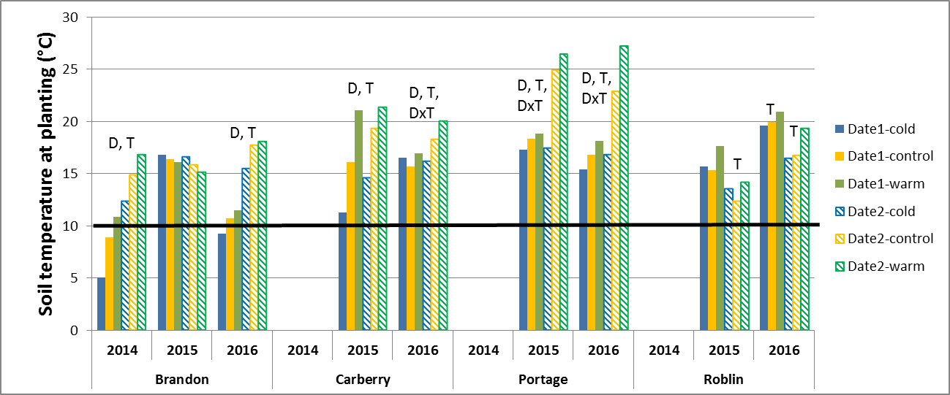

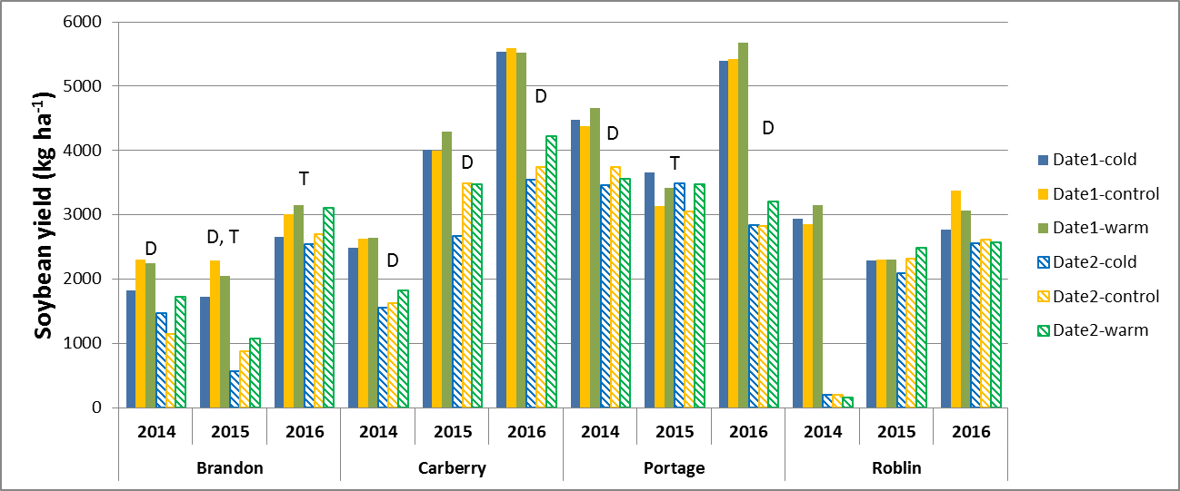

Figure 2. Effect of planting date and soil temperature treatment on soil temperature measured at time of planting and on soybean yield at Brandon, Carberry, Portage and Roblin (2014-16). (D, T and DxT indicate significant (P≤0.05) effects of planting date (D), temperature treatment (T), and DxT interactions based on analysis of variance.)

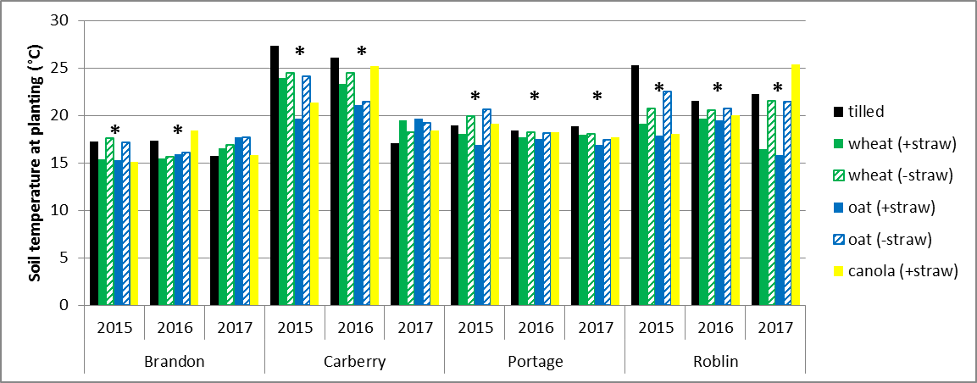

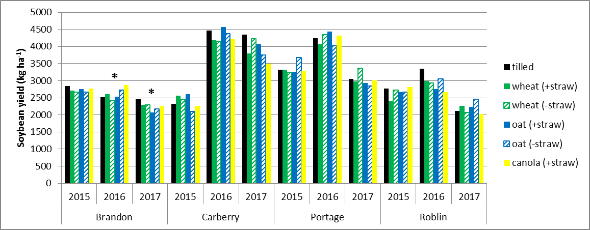

Figure 3. Effect of residue management practices on soil temperature measured at time of planting and on soybean yield at Brandon, Carberry, Portage and Roblin (2015-17). (* indicates a significant (P≤0.05) effect of residue management treatment based on analysis of variance by site-year.)

***Acknowledgements:*** Funding for this research was provided by the Manitoba Pulse and Soybean Growers, the Western Grains Research Foundation (WGRF), and the Agri-Food Research and Development Initiative (ARDI). Collaborating researchers were Aaron Glenn (AAFC-Brandon), Craig Linde (CMCDC-Carberry), and James Frey (PCDF-Roblin). Our thanks to the staff and students at AAFC-Brandon, CMCDC-Carberry and Portage, and PCDF-Roblin for their contributions to this research study.